* **Activity 6:**

### Grouping by More Than One Column

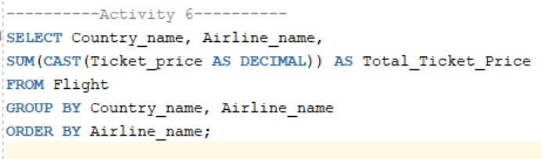

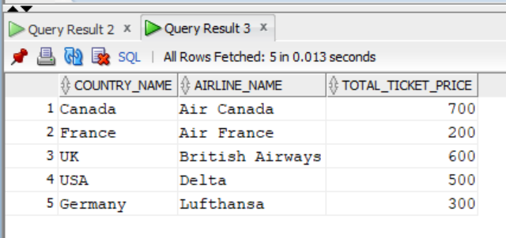Output: